JOB TITLE: | Nations and Branches Manager
TEAM: | National Outreach & Engagement
JOB HOLDER: | N/A
REPORTS TO (JOB TITLE): | Head of National Outreach & Engagement
JOB PURPOSE

This new role is being introduced to manage relationships, to develop and then act as the organisation’s custodian of best practice with member volunteers across the UK and Ireland.
The role will take a particular responsibility for supporting the work carried out by member volunteers through 15 National Committees and Regional Branches who undertake a significant amount of volunteer activity to bring the knowledge, enjoyment and value of physics to diverse audiences from professional physicists to the general public.
The role will be the main point of contact for those who serve on the National and Branch Committees, making sure the volunteer led Committees are well run and driving improvements to how we support, communicate with and recognise the work of volunteers whilst ensuring that we respond swiftly to practical requests such as expenses. The post holder will work in close collaboration with our National and Regional Officers who are based across the UK and Ireland and responsible for a range of activities including helping those run through the Committees.
The development and maintenance of best practice for member volunteers will be led by the new role, working in collaboration with others across the organisation who work to support different types of volunteers.

ORGANISATIONAL STRUCTURE
An organisational chart showing where this job sits within the IOP

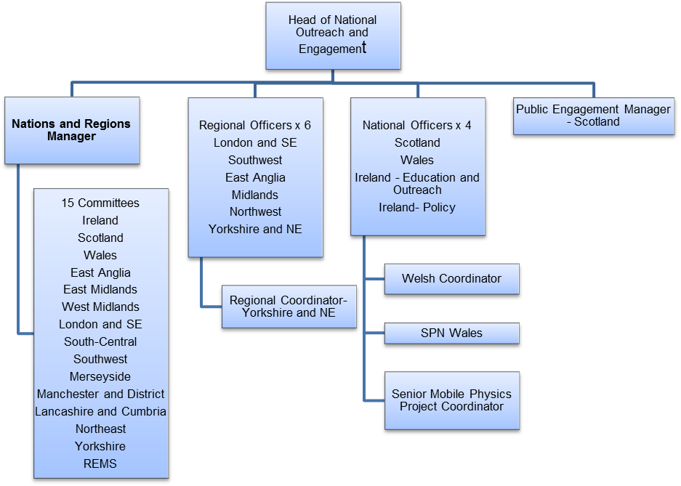

CONTEXT
This briefly sets out the necessary background, including the department’s purpose, to understand how the job fits into the organisation and how it relates to other functions or jobs in the organisation

The national outreach and engagement team’s purpose

An essential part of IOP’s mission is to widen the enjoyment and participation in physics by the general public and to grow national levels of science capital. We are passionate about widening participation and enjoyment of physics and the important role that it plays in our culture and society.
We do this through:

- A theme-led national public engagement programme with activities, exhibitions and events that target audiences ranging from disengaged youth to science enthusiasts. At the core of this programme is an annual creative commission that will take place in one or more cities around the UK and Ireland and also in the IOP’s London building in Kings Cross.

- Developing partnerships to deliver projects that connect physics with business, society and the arts. The team also has the national responsibility for helping to shape and oversee the delivery of IOP’s outreach to different audiences including universities, the teaching profession, physicists working in business and driving strong policy messages at National Government level.

- Facilitating best practice in public engagement, enabling and training our members and early career researchers to share their passion for physics with the public through outreach delivered by the IOP Nations and Branches.

- Demonstrating the impact that our work across the UK and Ireland through the development of an evaluation framework.

The Outreach and Engagement Department provides engagement activities directly to the public, and also works with members of the Institute of Physics through our Nations and Branches to deliver activities as volunteers.

The job’s context
Our member volunteer work includes the work undertaken through the IOP’s 15 national committees and branches across the UK and Ireland. Volunteer led and run with their own budgets and governance structures, they shape and deliver their local outreach and engagement programmes oriented towards the physics community and the wider public. Through this work, IOP is able to reach approximately 850,000 people each year and this number is growing.

We want to make sure we have a strong strategic and collaborative style of engagement with members through those who lead the nations and branches. This will ensure that we are both supporting and encouraging best practice in volunteer management whilst making sure that governance and financial framework is robust.

TASKS & ACCOUNTABILITIES

The responsibilities of the Nations and Branches manager will be:
- Overseeing and developing best practice for the nations and branches (N&B) structure within the IOP, including the processes to encourage and support national and regional committee membership
- Working with nations and branches, including their national and regional officers, to oversee annual budgets and financial forecasting, develop activity plans and reporting on impact
- Take responsibility for making sure that the meetings where nations and branch committee members share ideas and look at future direction are framed to maximise the value of volunteer attendance whilst driving IOP’s strategic direction
- Working in partnership with the National and Regional Officers to coordinate activities through nations and branches particularly in respect of the public engagement theme – in 2018 the theme is “Time”
- Collaborate with colleagues to drive business improvements and efficiencies and act as the champion and custodian of best practice in volunteer management
- Undertaken a thorough assessment of the current national and regional structure and with the Head of National Outreach and Engagement make recommendations to the executive team on how to improve national and regional networks, and then implement agreed changes. This will require a particularly proactive role with teams across the organisation in order to enhance national and regional effectiveness.

Specific duties include:

- Delivering through a strong governance and financial framework and working with the NROs to ensure a clear and consistent strategic direction is given to nations and branches that will drive the IOP’s national outreach and engagement programme and monitor outcomes
- Collaborating with the NROs and marketing team in reaching members not currently engaged in national and branch activities including those at universities, businesses and schools
- To work with the Science and Innovation Team (i.e. the group officers) to develop business processes/automation in support of common processes for special-interest groups and branch functions
- To review volunteering across the breadth of IOP activity and work to ensure IOP volunteers are consistently trained, supported and rewarded.
- Managing committee and branch expenses process and responding to queries from branch members
- Working with the Communications Team to ensure excellent communications of national and branch activities through the creation of content for IOP’s digital services including social media
- Ensuring that National and Branch Committee meetings are designed to maximise the value of member volunteer time and to drive forward key areas of IOP’s strategy

SCOPE OF DECISION MAKING / CHALLENGES

- The post-holder has a direct relationship with our volunteer members and must be able to ‘win the hearts and minds’ in order to deliver our national outreach and engagement programme in a way that is consistent and has impact for the organisation

- Able to work in collaboration with national and regional officer colleagues who are based across the UK and Ireland that reflects the different nature of their nations and regions, variances in committee structure yet still delivers a joined up programme

- Ensuring the activities of the N&B Committees operate within legal and strategic parameters whilst allowing them to maintain their relative autonomy. Examples include: ensuring members’ personal data is protected; proactively ensuring the adherence of the committee/nominations process.

DIMENSIONS

- The post-holder has no direct line reports. However, they will require tact and people management skills in the context of volunteer management as they are responsible for governance and strategic oversight of the IOP’s 14 volunteer-run Nations and Branches

- Responsible for taking a front line role with member volunteers in support of their activities and acting as the organisation’s custodian of best practice in volunteer management

- The post holder will need to work in close collaboration with National and Regional Officers as well as other colleagues across the organisation with the confidence and right diplomacy to drive up performance and best practice of their peers

- Has authority to sign off members’ expenses up to £5,000

- Responsibility for national committee and branch budgets c£250,000 per annum

- This role will involve regular travel across the UK and Ireland and some out of hours working

KNOWLEDGE, SKILLS & EXPERIENCE
The below are the skills, qualifications, membership requirements and experiences that are necessary for full and effective performance of this role, unless stated otherwise

Skills
- Governance – ability to understand committee rules and guidelines and the confidence and authority to communicate them to members and staff
- Working with volunteers – able to deliver best practice in volunteer management, providing support that values their time
- Communication – able to deliver the right tone and language to use in communications with volunteers
- Influencing skills-- the ability to bring others to your way of thinking diplomatically
- Flexibility – the ability to adapt a plan of work whilst responding to changing circumstances
- Team player – the ability to work co-operatively with others to achieve common goals
- Proactive – to think ahead and act to ensure the smooth completion of team / individual aims and objectives
- Dependable – able to complete tasks to high standard and to deadline
- Organisational skills – ability to work with minimum supervision, prioritise workload, and handle multiple tasks
- Interpersonal skills – ability to positively communicate with others; the confidence to listen and understand

- Communication skills – ability to express information clearly and effectively in written and oral form

- Computer literate – good working knowledge of Microsoft Office
- Attention to detail

Experience

- At least five years’ experience providing governance and strategic direction support to volunteer groups, committees or organisations
- Proven experience of managing networks of people with varying interests and motivations
- Demonstrable experience of leading change and applying best practice in a membership or volunteer environment
- Designing meetings of volunteers to achieve maximum benefit in support of an organisation’s strategic direction
- Experience of balancing the provision of hand on excellent logistics and co-ordination alongside strategic responsibilities
- Management and reporting on budgets in excess of £50,000

COMPETENCIES
The behaviours that must be demonstrated in the job
- Strategic overview of governance
- Drive for results – Can be counted on to meet or exceed goals successfully, implemented against strategic priorities
- Managing and measuring work – Takes responsibility for tasks and decisions
- Customer focus – Is dedicated to meeting the expectations and requirements of internal and external members/ customers / partners
- Functional/technical skills – Has the functional and technical knowledge and skills to do the job at a high level of accomplishment
- Personal learning – Picks up on the need to change personal, interpersonal, and where applicable managerial behaviour quickly
- Managing relationships with other teams or stakeholders with different priorities

