JOB TITLE: | Regional Manager NW of England
DEPARTMENT: | Outreach & Engagement
JOB HOLDER:
REPORTS TO (JOB TITLE): | Head of Outreach and Engagement
JOB PURPOSE
This is a summary, in a few sentences/bullet points, of the overall contribution this job makes to the IOP

To increase the IOP’s activity, profile and influence with members and stakeholders within the North West of England in line with IOP strategy. To develop and deliver a programme of public engagement to build science capital in the NW through strategic partnerships and supporting our membership in their delivery of outreach.

ORGANISATIONAL STRUCTURE
An organisational chart showing where this job sits and the jobs immediately around it

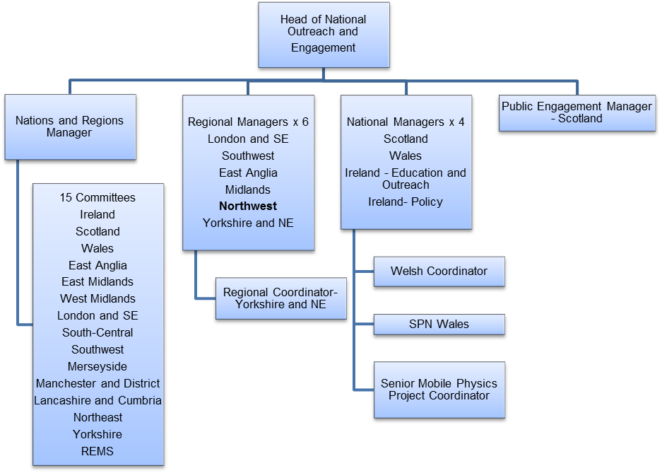

CONTEXT
This briefly sets out the necessary background, including the department’s purpose, to understand how the job fits into the organisation and how it relates to other functions or jobs in the organisation

Regional managers represent the Institute of Physics in the English regions and are responsible for enabling the delivery of Institute strategy on a regional basis. This work is responsive to Institute needs as well as the local (regional) context, but is necessarily cross-strategy, with an emphasis on public engagement. In 2019, the IOP’s National Public Engagement Programme will kick off in Manchester with a creative commission in developed in partnership with a Manchester based arts organisation.

The NW Regional Manager’s work spans, but is not limited to the following areas.

Community – To support IOP membership regionally and raise the profile of the IOP within the physics community. To work as a link between Branches and the Institute and support their activity as required.

Discovery – To support the Institute’s work to strengthen the core discipline of physics and support physicists in their careers.

Economy – To raise the profile of the IOP with stakeholders in physics based businesses and industry, building relationships and brokering collaborations; To raise the profile of the economic value of physics;

Society –Development and delivery of public engagement activity within the region. Develop strategic partnerships with local partners to reach underserved communities, work with the Outreach and Engagement Team to enable the delivery of the National Public Engagement Programme. Raising the profile of physics and the IOP with local policymakers.

Education – To stay abreast of key IOP messages regarding education and gender balance in particular; to raise awareness of the value of a physics education and associated career pathways.

The role requires extensive travel throughout the North West region and occasional travel to the IOP London office. This involves some weekend and non-core working hours to attend events and meetings including occasional overnight stays

TASKS & ACCOUNTABILITIES
A list of 6 – 8 statements identifying the principal tasks required of the job, which integrate to achieve the purpose of the job.
The role includes the following tasks and accountabilities. The balance of these for an individual Regional Manager will depend on the needs of the region, opportunities available and Institute priorities.

1. To build, engage and support the Institute of Physics membership regionally
- To support 3 North West branch committees (Lancashire & Cumbria, Manchester District and Merseyside) and their engagement with IOP strategy
- To ensure recruitment, retention and engagement of members within the region
- To facilitate engagement with student members and student societies within the region

2. To raise the profile of the IOP within physics based businesses and industry
- To develop relationships with key business and industry stakeholders within the region
- To liaise with the IOP’s science and innovation team with regards to the Economy theme within the region, feeding in intelligence, identifying areas for collaboration and supporting delivery of projects.
3. To facilitate and deliver public engagement activity in the Northwest in line with IOP Outreach and Engagement strategy

- Initiate, develop & maintain partnerships with relevant stakeholders within the regional science community, cultural sector, and with community organisations
- To engage with cultural and community partners in Manchester in relation to the 2019 creative commission and develop a programme locally engaging with the National Programme theme or Big Data
- To work collaboratively with the Outreach and Engagement team to deliver a coherent public engagement programme.
- Liaise with the local IOP Branches and facilitate the recruitment of volunteers and delivery of high quality outreach activities

4. To support IOP’s work to strengthen the core discipline of physics and support physicists in their careers
- Engagement with university Heads of Departments around IOP activity as appropriate
- Collaboration with Member Services team around promotion of CPD & professional registration and delivery of events to support and engage early career physicists
5. To stay abreast of key IOP messages regarding education and gender balance in particular; to raise awareness of the value of a physics education and associated career pathways
- Development of partnership events that promote physics careers to young people, teachers, parents, carers and other key influencers.
- Facilitate contributions to major regional careers fairs
- Engagement with regionally based teaching and learning coaches, physics network coordinators as needed
6. To ensure good communications regarding IOP activity regionally

- Contribute to externally facing written communications as necessary (e.g, blog posts, press releases, newsletters)
- Contribute to internal communications and data collection as necessary.(e.g, reports & evaluations, updating the Confluence and Salesforce internal systems)
7.To raise the profile of physics and the IOP policy makers
- Engage with local MPs about the value of physics education and the value of the physics economy
- Work with the IOP’s Policy Centre to ensure dissemination of key policy messages amongst regional stakeholders and membership
- Participation on high profile events on behalf of the IOP as appropriate

SCOPE OF DECISION MAKING / CHALLENGES
A summary, of no more than the 4 key main decisions/challenges the post holder may face in carrying out the accountabilities of this job.

- Building and maintaining key stakeholder partnerships including partners in the wider community as well as IOP branches, groups and other IOP stakeholders.

- Managing expectation of individual IOP member and Branch committees

- Planning ahead and managing multiple projects at the same time to ensure that a full programme of activities is successfully delivered on time and to budget
DIMENSIONS
A summary of any numerical facts and figures that are relevant to illustrate the scale of the role e.g.
- Management of budget of ~£10,000
- Ability to sign off invoices up to (£1,500)
- No direct line reports, but requires extensive relationship management with IOP colleagues, stakeholders and members
- Requires independent home-based working as this position is not based in an IOP office
- Requires extensive travel across the North West region of England and trips to London and elsewhere in the UK. It is expected that the RO will reside in the North West region.

KNOWLEDGE, SKILLS & EXPERIENCE
What skills, qualifications and experience are necessary for full and effective performance?

Skills

- Team player – the ability to work co-operatively with others to achieve common goals
- Proactive – to think ahead and act to ensure the smooth completion of team / individual aims and objectives
- Dependable – able to complete tasks to high standard and to deadline
- Organisational skills - ability to work with minimum supervision, prioritise workload, and handle multiple tasks
- Interpersonal skills – ability to positively communicate with others; the confidence to listen and understand
- Self-motivating –ability to work independently from the rest of the public engagement & national and regional manager team and remain focussed
- Excellent communication skills, written and oral
- Computer literate - good working knowledge of Microsoft Office
- Access to appropriate transport to get to all parts of the region; some of which will be difficult to access via public transport.

Qualifications / Membership requirements

- A degree, or equivalent professional experience, in physical sciences or engineering

Experience
Essential
- Experience of engaging and supporting volunteers
- Experience of building and maintaining networks with stakeholders & collaborators and building consensus
- Experience of administration & management of multiple projects
- Knowledge of the North West physics landscape (STEM outreach, schools/colleges, HEI’s and business/industry)
Desirable
- Working in science communication, including experience of:
  - delivering public engagement activities
  - collaborations with partners in the cultural sector
  - making the link between activities and future career options
  - working with varied stakeholders and partners including scientists and volunteers
- Knowledge of the higher education system including the different needs and priorities of students and staff
- Experience of working with schools and an awareness of the English school system
COMPETENCIES
The behaviours that must be demonstrated in the job.

- Leadership – Becomes recognised internally and externally for expertise, insight and ability to drive forward and develop projects
- Interpersonal Skills -- ability to positively communicate with others; the confidence to listen and understand
- Communication skills – Good written and oral communication skills
- Drive for results – Can be counted on to meet or exceed goals successfully
- Managing and measuring work – Takes responsibility for tasks and decisions
- Customer focus – Is dedicated to meeting the expectations and requirements of internal and external customers / partners
- Functional/technical skills - Has the functional and technical knowledge and skills to do the job at a high level of accomplishment
- Personal learning - Picks up on the need to change personal, interpersonal, and where applicable managerial behaviour quickly

DATE:
Signed: (Job Holder)
Signed: (Manager / Director)

