JOB TITLE: |  | Marketing Officer  Part time (3.5 days per week)  Fixed term contract until 31 May 2021
DEPARTMENT: |  | Education
JOB HOLDER: |  | N/A
REPORTS TO (JOB TITLE): |  | Project Manager (KEEP Teaching)
JOB PURPOSE
This is a summary, in a few sentences/bullet points, of the overall contribution this job makes to the Institute of Physics (IOP)

Lead the delivery of marketing activities and campaigns for recruitment into the KEEP Teaching Project, working with external stakeholders to achieve recruitment objectives.
Provide the marketing expertise needed to iteratively review, evaluate and develop the marketing and recruitment processes throughout the duration of the project.
Support the Project Manager with reporting requirements, and by escalating any risks or issues with the marketing and recruitment activity of the project.
ORGANISATIONAL STRUCTURE
An organisational chart showing where this job sits within the IOP

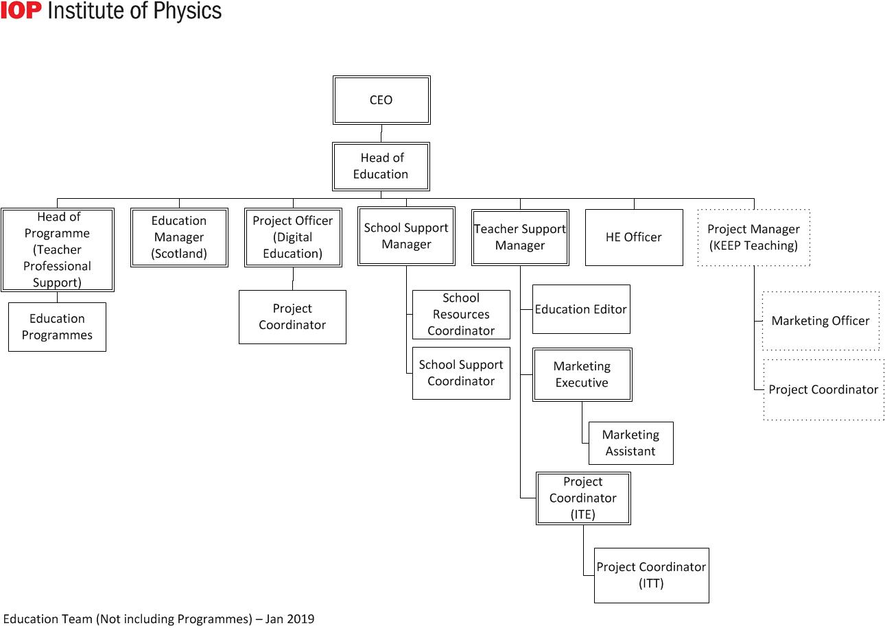
CONTEXT
This briefly sets out the necessary background, including the department’s purpose, to understand how the job fits into the organisation and how it relates to other functions or jobs in the organisation

The department’s purpose

The Education Department covers a broad range of activities around two basic themes:
- Ensuring the supply of physicists from the education system and assuring, as far as possible, the quality of their education
- Promoting physics-based research both through member networks and by engaging with research councils, funding councils, government and other funding agencies

Operationally, the Directorate is split into three areas:
- Higher Education and Research
- Education Pre-19
- Diversity and Inclusion

The job’s context

The KEEP Teaching Project (Keeping Early-Career Physicists Teaching) is a national education research trial funded by the Education Endowment Foundation and Wellcome, managed by The Institute of Physics, and independently evaluated by UCL’s Institute of Education. It is a randomised control trial, which will be run over 3 academic years, investigating an intervention which aims to increase the job satisfaction of newly-qualified, physics teachers (NQT). The project needs to recruit and retain at least 300 participants, 100 each year. A participant is a pair; made up of a newly-qualified physics teacher and their school employer.

The scope of the role includes coordinating all marketing, promotional and awareness activity for the project, including marketing to potential participants and also creating content to share with funders and wider audiences post-project. The Marketing Officer will lead the formal recruitment of participants to the trial once they have registered an interest which will involve further marketing of the trial by phone and email.

TASKS & ACCOUNTABILITIES
A list of 6 – 12 statements identifying the principal outputs required of the job, which integrate to achieve the purpose of the job.

1 | Coordinate the delivery of the marketing and recruitment strategy for the trial:  - Work with internal and external stakeholders  - Use integrated marketing channels to help achieve project objectives  - Report, evaluate, and provide recommendations for marketing and recruitment
2 | Support the development of content for the trial:  - Work with internal and external designers to create marketing materials for on and offline use  - Write, proof read, and evaluate copy
3 | To identify and recruit eligible participants to the trial, including:  - Carry out market research to identify eligible schools and trainee teachers  - Liaising with field workers to intensify recruitment efforts of schools where needed, offering advice and guidance if required.  - Making initial contact with eligible participants  - Leading the formal recruitment of both parties (school and NQT) by contacting them directly by phone/email
4 | Work with digital marketing tools, including:  - Google Analytics  - Email marketing client
5 | Coordinate the project’s presence at events for the purpose of recruitment to the trial:  - Identify appropriate events and maintain a calendar  - Attend events to register interested teachers or schools  - Develop and deliver presentations at relevant events  - Evaluate success of events and use learning to inform future events
6 | Work with compliant data management processes  - Collect and process data of eligible participants  - Keep data up-to-date using Salesforce
7 | Monitor and report on spend for marketing activities
8 | Any other reasonable duties as requested:  Promote the project internally using existing communication channels

SCOPE OF DECISION MAKING / CHALLENGES
A summary, of no more than the 4 key main decisions/challenges the post holder may face in carrying out the accountabilities of this job.

Implementing and evaluating the recruitment and marketing strategy
Influencing participants to commit formally to the trial
Dissuading participant attrition from the project
Working effectively with field staff to reach recruitment objectives

DIMENSIONS
A summary of any numerical facts and figures that are relevant to illustrate the scale of the role e.g.

- The Marketing Officer has no direct line reports, but is responsible for tight touch supervision over field. workers involved in recruitment, in conjunction with the Project Manager (KEEP Teaching).
- Can authorise project expenditure up to £1500.
- Responsible for the recruitment of at least 300 participants.

KNOWLEDGE, SKILLS & EXPERIENCE
The below are the skills, qualifications, membership requirements and experiences that are necessary for full and effective performance of this role unless otherwise stated

Skills

- Team player – the ability to work co-operatively with others to achieve common goals
- Negotiation skills – the capability to explore different positions and alternatives to reach outcomes that gain acceptance of all parties
- Influencing skills - the ability to bring others to your way of thinking diplomatically, including senior members of staff in schools in order to recruit them to the project
- Proactive – to think ahead and act to ensure the smooth completion of team / individual aims and objectives
- Dependable – able to complete tasks to high standard and to deadline
- Organisational skills - ability to work with minimum supervision, prioritise workload, and handle multiple tasks
- Interpersonal skills – ability to positively communicate with others; the confidence to listen and understand
- Communication skills - ability to express information clearly and effectively in written and oral form, especially over the telephone

- Computer literate - good working knowledge of Microsoft Office and of HTML email marketing software
- Attention to detail - ensure that activities and communications adhere with our core messaging and brand guidelines.

Qualifications / Membership requirements
Essential:
- Degree or equivalent vocational experience

Desirable:
- Marketing qualification

Experience
Essential:
- Proven ability of marketing in some previous role
- Proven ability to deal tactfully with a wide range of people
- Experience of producing marketing materials
- Experience administering CRM systems
- Experience collecting and managing data in accordance with GDPR

Desirable:
- Experience of using a clear system of monitoring impact and evaluation of marketing activities – highly desirable
- Experience of managing stands at events
- Experience of working with or in schools

COMPETENCIES
The behaviours that must be demonstrated in the job

- Drive for results – Can be counted on to meet or exceed goals successfully
- Managing and measuring work – Takes responsibility for tasks and decisions
- Customer focus – Is dedicated to meeting the expectations and requirements of internal and external customers / partners
- Functional/technical skills - Has the functional and technical knowledge and skills to do the job at a high level of accomplishment
- Personal learning - Picks up on the need to change personal, interpersonal, and where applicable managerial behaviour quickly

