JOB TITLE: |  | Project Coordinator (KEEP Teaching)  Part time (3.5 days per week)  Fixed term contract to 31 July 2022
DEPARTMENT: |  | Education
JOB HOLDER: |  | N/A
REPORTS TO (JOB TITLE): |  | Project Manager (KEEP Teaching)
JOB PURPOSE
This is a summary, in a few sentences/bullet points, of the overall contribution this job makes to the Institute of Physics (IOP)

Coordinate the project’s intervention in schools, supporting schools, creating and giving advice throughout the duration of the project.

Provide administrative support to the project, working with the Project Manager and Marketing Officer to ensure the successful delivery of the project.

ORGANISATIONAL STRUCTURE
An organisational chart showing where this job sits within the IOP

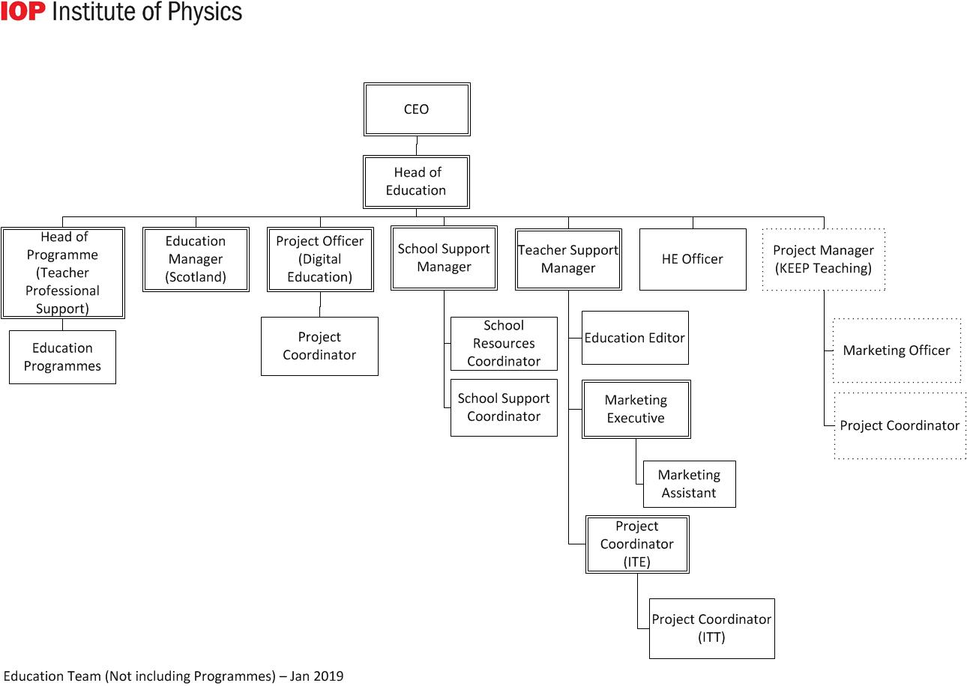
CONTEXT
This briefly sets out the necessary background, including the department’s purpose, to understand how the job fits into the organisation and how it relates to other functions or jobs in the organisation

The department’s purpose

The Education Department covers a broad range of activities around two basic themes:
- Ensuring the supply of physicists from the education system and assuring, as far as possible, the quality of their education
- Promoting physics-based research both through member networks and by engaging with research councils, funding councils, government and other funding agencies

Operationally, the Directorate is split into three areas:
- Higher Education and Research
- Education Pre-19
- Diversity and Inclusion

The job’s context

The KEEP Teaching Project (Keeping Early-Career Physicists Teaching) is a national education research trial funded by the Education Endowment Foundation and Wellcome, managed by The Institute of Physics, and independently evaluated by UCL’s Institute of Education. It is a randomised control trial, which will be run over 3 academic years, investigating an intervention which aims to increase the job satisfaction of newly-qualified, physics teachers. The project needs to recruit and retain at least 300 participants, 100 each year. A participant is a pair; made up of a newly-qualified physics teacher and their school employer.

The post-holder will coordinate the trial’s intervention, offering guidance and support to schools where needed, and reviewing their engagement with the intervention. Additionally they will provide administrative support to the project generally, organising and supporting project meetings, and assisting with report writing and stakeholder management.

Some administrative support of the recruitment phase of the project may also be needed, for example, assisting the Marketing Officer with market research, proof-reading copy, and database report generation.
TASKS & ACCOUNTABILITIES
A list of 6 – 12 statements identifying the principal outputs required of the job, which integrate to achieve the purpose of the job.

1 | Coordinate the creation and evaluation of support materials for schools involved in the trial:  - Create written guidance for schools to enable them to efficiently deploy the intervention  - Review and monitor schools’ engagement with the trial, intervening where necessary to offer further guidance or escalating to field workers and Project Manager.  - Annually review and evaluate the guidance, using the previous year’s learnings to update them
2 | To provide administrative support to the project:  - Arrange and administer project meetings as required  - Handle routine enquiries from colleagues, field workers, partners and schools in a professional and efficient manner  - Contribute to the necessary reporting and documentation processes as required from the project’s funders  - Help maintain the database of schools and teachers engaged in the project
3 | Coordinate the delivery of financial incentives to participants:  - Liaise with evaluators to determine whether participation has been sustained as required.  - Monitor participation in the trial of both the control and experimental groups.
4 | To support the work of the other project team members, especially the project manager, as required.
5
6
7
8
9
10
11
12

SCOPE OF DECISION MAKING / CHALLENGES
A summary, of no more than the 4 key main decisions/challenges the post holder may face in carrying out the accountabilities of this job.

DIMENSIONS
A summary of any numerical facts and figures that are relevant to illustrate the scale of the role e.g.

- The Project Coorindator has no direct line reports, but may coordinate field workers to support the intervention in schools, in conjunction with the Project Manager (KEEP Teaching)
- Can authorise project expenditure up to £500
- Works with the team to maintain a yearly cohort of 100 participants

KNOWLEDGE, SKILLS & EXPERIENCE
The below are the skills, qualifications, membership requirements and experiences that are necessary for full and effective performance of this role unless otherwise stated

Skills

- Team player – the ability to work co-operatively with others to achieve common goals
- Influencing skills - the ability to bring others to your way of thinking diplomatically
- Proactive – to think ahead and act to ensure the smooth completion of team / individual aims and objectives
- Dependable – able to complete tasks to high standard and to deadline
- Organisational skills - ability to work with minimum supervision, prioritise workload, and handle multiple tasks
- Interpersonal skills – ability to positively communicate with others; the confidence to listen and understand

- Communication skills - ability to express information clearly and effectively in written and oral form

- Computer literate - good working knowledge of Microsoft Office /

Qualifications / Membership requirements

- Interest in education
- Educated to A-level standard or equivalent vocational experience

Experience

Essential:
- Experience of administration and working in an office environment
- Experience of working in or with the education sector
- Experience of multi-tasking in a small team

Desirable:
- Experience working in projects, and the associated administrative tasks
- Experience of administering CRM systems

COMPETENCIES
The behaviours that must be demonstrated in the job

- Drive for results – Can be counted on to meet or exceed goals successfully
- Managing and measuring work – Takes responsibility for tasks and decisions
- Customer focus – Is dedicated to meeting the expectations and requirements of internal and external customers / partners
- Functional/technical skills - Has the functional and technical knowledge and skills to do the job at a high level of accomplishment
- Personal learning - Picks up on the need to change personal, interpersonal, and where applicable managerial behaviour quickly

