JOB TITLE: |  | Public Engagement Officer
DEPARTMENT: |  | London Outreach and Engagement
JOB HOLDER: |  | N/A
REPORTS TO (JOB TITLE): |  | Public Programmes Manager
JOB PURPOSE
This is a summary, in a few sentences/bullet points, of the overall contribution this job makes to the Institute of Physics (IOP)

To devise and implement physics-based public engagement activities for the London Outreach and Engagement team and support the physics outreach activities of IOP members.

ORGANISATIONAL STRUCTURE
An organisational chart showing where this job sits within the IOP – please refer to attached

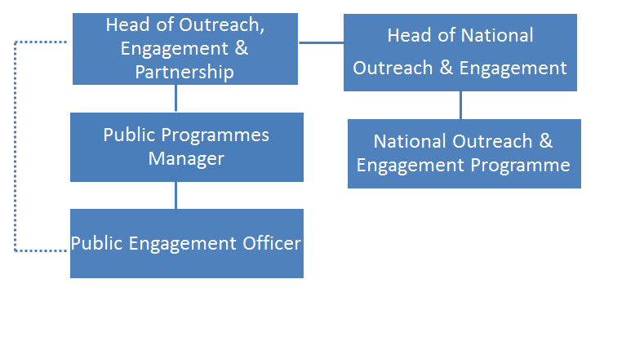

CONTEXT
This briefly sets out the necessary background, including the department’s purpose, to understand how the job fits into the organisation and how it relates to other functions or jobs in the organisation

The department’s purpose
The Outreach and Engagement Department is responsible for Institute of Physics activities that engage the public with physics. There are two programmes: the National programme works around the UK and Ireland and the London Programme focuses on public engagement through the IOPs new building in Kings Cross.
Both these outreach and engagement programmes:

- Work to widen the participation and enjoyment of physics and to raise the important role that physics plays in our culture and society
- Facilitate best practice in public engagement, enabling our members and early career researchers to share their passion for physics with the public
- Develop partnerships to deliver projects that connect physics with business, society and the arts.

The job’s context

IOP’s London Outreach & Engagement programme runs out of the IOP’s new purpose-built building in Kings Cross which, for the first time, gives the IOP public facing spaces To achieve our ambitions for public engagement with impact in London we need to advance public engagement with our key audiences (families and adults new to physics plus the physics community) through the new building and community links and partnerships.

The programme engages the public through the creation and delivery of exhibitions in the new gallery space, with supporting programmes of public events, delivers an annual series of science cafes, works with local community groups in Islington and oversees public engagement with young people in Islington primary and secondary schools to complement the IOP’s Education department’s work with teachers.

TASKS & ACCOUNTABILITIES
A list of 6 – 12 statements identifying the principal outputs required of the job, which integrate to achieve the purpose of the job.

1 | Organising events – Design, manage and evaluate events with Islington community groups, both hosted at our building and at venues across Islington, The managing will include sourcing venues and the marketing of events. This includes events as part of our 1.06 commitment, including 4 Science Cafes a year and occasionally delivering public engagement workshops with school-aged children in schools and in the London building, as required.
2 | Community partnerships – develop new and existing partnerships with local community groups in Islington and Camden
3 | Schools engagement – working with young people in primary and secondary schools in Islington in parallel with the IOP’s Education programme
4 | Gallery programming – Support the Public Programmes Manager in coordinating gallery content. Organise events to support these shows and to draw the public into the gallery space including: venue sourcing; marketing/ advertising events; evaluation of events;
5 | Partnership building – sourcing potential collaboration partners from Islington and King’s Cross community groups and supporting the Head of London O&E in building relationships.
6 | Physics in the building – Support Public Programmes Manager with the physics in the building project including developing the Explore Physics website and resources.

SCOPE OF DECISION MAKING / CHALLENGES
A summary, of no more than the 4 key main decisions/challenges the post holder may face in carrying out the accountabilities of this job.

- Planning ahead and working on multiple projects at the same time to ensure that the full programme of activities is delivered on time

- Being creative and innovative to ensure all projects meet the aims of the outreach and engagement strategy and are truly engaging for non-physicists

- Good judgement in developing partnerships with community groups in Islington and in working with IOP members and other volunteers in delivering and supporting public events

DIMENSIONS
A summary of any numerical facts and figures that are relevant to illustrate the scale of the role e.g.

- People management – number of direct line reports, function managed, who the post holder reports to
- Annualised financial data – costs/orders/sales/revenue budgets and different currencies used if applicable
- Other relevant statistics – projects managed

- The Public Officer has no direct line reports, and reports to the Public Engagement Manager, with functional reporting to Head of London Outreach, Engagement & Partnerships

- Has no authority to sign off invoices

- Manages projects that need to keep within agreed budgets of circa £20k pa

KNOWLEDGE, SKILLS & EXPERIENCE
The below are the skills, qualifications, membership requirements and experiences that are necessary for full and effective performance of this role unless otherwise stated

Skills
- Good judgement – significant experience of working with diverse community groups
- Team player – the ability to work co-operatively with others to achieve common goals
- Proactive – to think ahead and act to ensure the smooth completion of team / individual aims and objectives
- Dependable – able to complete tasks to high standard and to deadline
- Creative thinking – ability to generate ideas and develop them into feasible projects
- Organisational skills - ability to work with minimum supervision, prioritise workload, and handle multiple tasks
- Interpersonal skills – ability to positively communicate with others; the confidence to listen and understand

- Excellent communication skills, written and oral

- Computer literate - good working knowledge of Microsoft Office

Qualifications / Membership requirements

- A degree in physics or equivalent experience in and understanding of physics
- A relevant qualification in science communication - desirable

Experience

- Working in science communication, including experience of:
  - devising and delivering public engagement activities, including evaluation
  - managing several projects simultaneously
  - working with varied stakeholders and partners including scientists and volunteers
  - working with young people in schools
  - working with diverse community groups
COMPETENCIES
The behaviours that must be demonstrated in the job

- Drive for results – Can be counted on to meet or exceed goals successfully
- Managing and measuring work – Takes responsibility for tasks and decisions
- Customer focus – Is dedicated to meeting the expectations and requirements of internal and external customers / partners
- Functional/technical skills - Has the functional and technical knowledge and skills to do the job at a high level of accomplishment
- Personal learning - Picks up on the need to change personal, interpersonal, and where applicable managerial behaviour quickly

