JOB TITLE: |  | IOP Coach (Gender - Wales)  Fixed term: until March 2020
DEPARTMENT: |  | Education
REPORTS TO (JOB TITLE): |  | Project Manager (Education, Wales)
JOB PURPOSE: To lead a group of primary and secondary schools to tackle the barriers to girls’ progression into physics. Based on our Drayson pilot project, the Coach will work with schools to improve the gender balance in subject choice across the school, with a specific focus on physics.

The coach will support teachers and senior management to implement a school wide programme to create/maintain an inclusive culture within the school as well as supporting teachers to run specific interventions to increase the science capital of girls; help them identify with science and careers with physics; make physics teaching more engaging and inclusive, and encourage gender equality messages to propagate through the school.

The coach will deliver network events and training as well as supporting individual schools. This role may also include training others to run similar training in their areas.
ORGANISATIONAL STRUCTURE
An organisational chart showing where this job sits within the IOP. This organisational structure is currently under review.

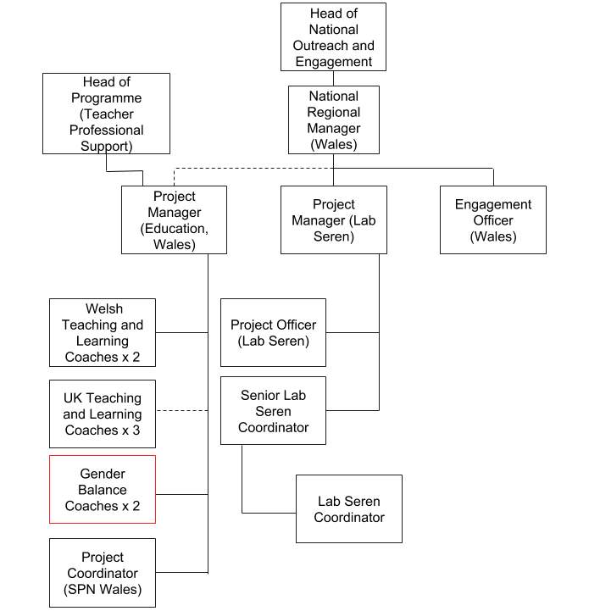
CONTEXT
This briefly sets out the necessary background, including the department’s purpose, to understand how the job fits into the organisation and how it relates to other functions or jobs in the organisation

The department’s purpose

The Education Department covers a broad range of activities around two basic themes:
- Ensuring the supply of physicists from the education system and assuring, as far as possible, the quality of their education
- Promoting physics-based research both through member networks and by engaging with research councils, funding councils, government and other funding agencies

Operationally, the Directorate is split into three areas:
- Higher Education and Research
- Education Pre-19
- Diversity and Inclusion

The department operates as a team running a wide variety of activities and services to support physics in schools and colleges. These include:
- advice and training for teachers on developments in education and physics
- an Affiliated Schools scheme that provides resources including newsletters, posters and careers material
- the development of major resources such as Advancing Physics and Supporting Physics Teaching (SPT)
- the Physics Teacher Network
- publication of the journal Physics Education
- production of careers materials and classroom resources
- support for lectures, competitions and careers material for young people

The job’s context

The proportion of girls nationally has remained at or around 21% of the A-level cohort for the last three decades. The Institute has been working for over fifteen years on trying to improve the gender balance in the take-up of physics at A-level and beyond. We know that better physics teaching increases the progression to A-level physics and that this disproportionately affects girls. The Coach will to work with science departments to increase the standard of physics teaching in target schools. However, to improve the gender balance in physics, more needs to be done.

Through our previous work, we know that whole-school environment plays a role in the likelihood of girls progressing onto study A level physics. The Coach will be facilitating interventions, based on our Drayson pilot work in the Improving Gender Balance project.

The Coach will be supporting teachers to make change within their schools. Specifically, they will:
- Develop commitment from the SLT and teachers in the partner schools; facilitate and monitor activity to allow impact to be assessed
- Work with the staff on whole-school approaches to tackling gender imbalance and stereotyping.
- Support school staff to run interventions to increase science capital and build confidence for secondary school girls.
- Be flexible in their approach to the needs of the school and put in place a supportive programme of support aligned to the Drayson pilot interventions
- Foster collaboration between schools to share best practice and expertise
- Attend regional team meetings (approx. 3 times a year)
- Manage the budget for meetings and activities in schools

TASKS & ACCOUNTABILITIES
A list of 6 – 12 statements identifying the principal outputs required of the job, which integrate to achieve the purpose of the job.
1 | To co-ordinate with the IOP colleagues with regards to the engagement of schools
2 | To engage and maintain support for whole school gender work with SLT  - By delivering an initial launch event, where the offer is outlined to attending schools  - By discussing school policy and progression data with SLT  - By organising an equality audit
3 | To facilitate whole school work on gender stereotypes, careers and equality  - By delivering unconscious bias training/CPD for staff  - An initial meeting with key staff leads to help them plan activity across the school  - Support around parental outreach  - Remote support to lead teachers
4 | To support teachers to run specific interventions to increase the science capital of girls and help them identify with science  - By suggesting research projects and resources  - By organising and running STEM ambassador days  - By answering queries from schools
5 | To contribute to providing a centralised remote support service, which will help both schools that we are directly working with and other schools that are interested in improving gender equality of their schools.  The centralised remote support service entails:  - a suite of resources, hosted on Talk Physics  - an online community space, where teachers can share ideas  - a regular newsletter, pointing the way to our resources and other organisation’s resources (e.g. Let Toys be Toys), and other relevant content.
6 | To attend management group meetings in London and Cardiff (circa 3/4 times a year) and other regional meetings
7 | To provide regular (monthly) progress reports and to report back to management on any issues that may arise.
8 | To develop expertise and clout in the area of improving gender balance in schools.
9 | Liaise with the evaluation team and ensure that valid evaluation can take place.

SCOPE OF DECISION MAKING / CHALLENGES
A summary, of no more than the 4 key main decisions/challenges the post holder may face in carrying out the accountabilities of this job.

- Developing correct engagement interventions based on the best evidence available
- Gaining and maintaining credibility with the school, its staff and its senior leaders
- Pushing the project forward i.e. achieving results
DIMENSIONS
A summary of any numerical facts and figures that are relevant to illustrate the scale of the role e.g.
People management – number of direct line reports, function managed, who the post holder reports to
- Annualised financial data – costs/orders/sales/revenue budgets and different currencies used if applicable
- Other relevant statistics – projects managed

- The Gender Balance Officer has no direct reports
- Can authorize payment of invoices up to £2K

KNOWLEDGE, SKILLS & EXPERIENCE
The below are the skills, qualifications, membership requirements and experiences that are necessary for full and effective performance of this role unless otherwise stated

Skills
- Build and establish collaborative networks preferably in an education context
- Excellent communications skills
- Critical eye for research and theory
- Willingness to engage in the debate and development of ideas around inclusivity,
- Persuasive and confident dealing with stakeholders at all levels, including school SLT
- Advocacy skills
- Flexibility
- Experience of: leading CPD for teachers AND / OR working with children
- Training and coaching skills in gender, inclusivity and / or physics
- Team player – the ability to work co-operatively with others to achieve common goals
- Interpersonal skills – ability to positively communicate with others; the confidence to listen and understand
- Negotiation skills – the capability to explore different positions and alternatives so to reach outcomes that gain acceptance of all parties
- Influencing skills - the ability to bring others to your way of thinking diplomatically
- Proactive – to think ahead and act to ensure the smooth completion of team / individual aims and objectives
- Dependable – able to complete tasks to high standard and to deadline
- Able to work remotely and on own initiative
- Good working knowledge of Microsoft Office / computer literate
- Excellent analytical skills
- Excellent project management skills

Experience

- Experience of project management
- Significant experience of the way that Welsh secondary schools operate and the regulations and requirements (Curriculum, accountability measures etc) that bind them;
- Demonstrable knowledge of the issues of gender imbalance in subjects at school (particularly physics)
- Demonstrable understanding of the causes, effects and influences of gender stereotyping and how to counter them
- Proven ability to deal tactfully with a wide range of people
- Proven ability to gain trust and commitment from teachers and senior leaders in schools
- Willingness to travel to schools
- Ability to present and address a large audience with confidence
- Awareness of issues relating to evaluation of pilot projects

Desirable
- Physics teaching / coaching experience
- Welsh language skills

COMPETENCIES
The behaviours that must be demonstrated in the job

- Drive for results – Can be counted on to meet or exceed goals successfully
- Managing and measuring work – Takes responsibility for tasks and decisions
- Customer focus – Is dedicated to meeting the expectations and requirements of internal and external customers / partners
- Functional/technical skills - Has the functional and technical knowledge and skills to do the job at a high level of accomplishment
- Personal learning - Picks up on the need to change personal, interpersonal, and, where applicable, managerial behaviour quickly

