JOB TITLE: |  | Engagement Officer (Wales)
DIRECTORATE / DEPARTMENT: |  | Outreach and Engagement
JOB HOLDER: |  | N/A
REPORTS TO (JOB TITLE): |  | National Manager (Wales)
JOB PURPOSE
This is a summary, in a few sentences/bullet points, of the overall contribution this job makes to the Institute of Physics (IOP)

- To implement the Institute of Physics’ outreach and engagement strategy in Wales
- To work closely with the Institute of Physics’ membership in Wales.
- To support the National Manager in the implementation of the broader IOP strategy in Wales.

ORGANISATIONAL STRUCTURE
An organisational chart showing where this job sits within the IOP – please refer to attached

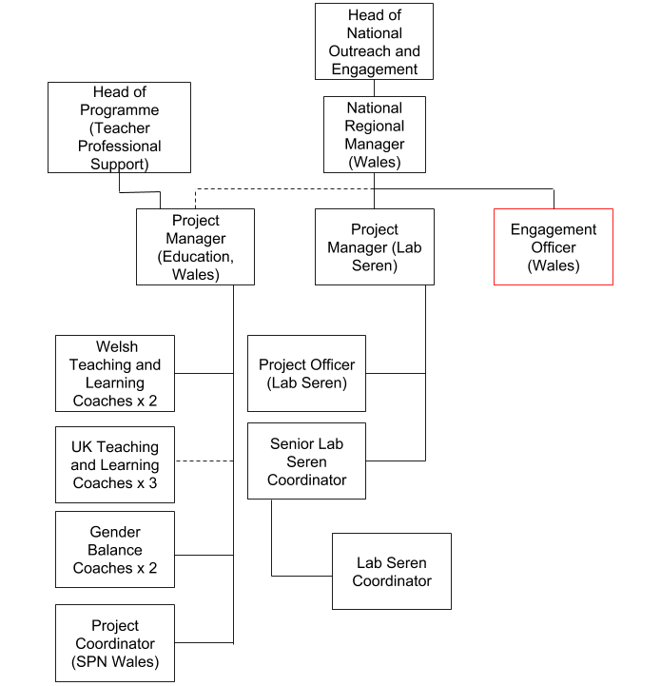
CONTEXT
This briefly sets out the necessary background, including the directorate and/or department’s purpose, to understand how the job fits into the organisation and how it relates to other functions or jobs in the organisation

The directorate/department’s purpose

The Outreach and Engagement Department is responsible for Institute of Physics activities that engage the UK and Irish public with physics.

We work to widen the participation and enjoyment of physics and to raise the important role that physics plays in our culture and society.

We facilitate best practice in public engagement, enabling our members and early career researchers to share their passion for physics with the public.

We develop partnerships to deliver projects that connect physics with business, society and the arts.

The job’s context

This role will be responsible for implementing a programme of public engagement in Wales, aligning this work with the Institute’s strategy. The post holder will develop and deliver projects that engage the public in dialogue around the importance of physics to society, and convene public debates which bring together experts and the wider public.

The role will be responsible for engagement with the IOP’s membership in Wales. This will include working closely with the IOP Wales committee to help them achieve their objectives and maintain alignment with the Institute’s strategy. The role is also responsible for growing the Institute’s membership and maintaining links with student societies in Wales.

This individual is responsible for organising events, coordinating volunteers, managing logistics and developing new outreach and engagement activities. They may have delegated budget responsibility up to ~£5000. The role may also occasionally involve assisting the National Manager with grant applications for new outreach and engagement projects.

This role will work collaboratively with stakeholders across the IOP, including the wider outreach and engagement team, membership team and project staff in Wales. The post holder will also collaborate with the Institute’s wider stakeholder network in Wales. The role may occasionally involve line management of project staff.

The post holder will also represent the IOP through contact with a number of external stakeholders, and will create new collaborations as well as managing existing relationships.

TASKS & ACCOUNTABILITIES
A list of 6 – 12 statements identifying the principal outputs required of the job, which integrate to achieve the purpose of the job.
1 | - To assist the National Manager for Wales and IOP Wales in delivering the Institute’s outreach and engagement strategy in Wales, including:  - Developing projects which engage the public in dialogue and debate around the role of physics in society and their everyday lives  - Delivering these projects (including volunteer coordination) at events across Wales.  - Seeking funding for the deployment of these projects.  - Delivering high profile science engagement activities (including volunteer coordination) at events across Wales.  - Working with stakeholder organisations and managing the Institute’s relationship with those organisations.  - Exploring new partnerships and opportunities
2 | - To grow and support the Welsh IOP membership  - To engage with physics students and apprentices in Wales, as well as university physics societies  - Work closely with the IOP Wales committee to support them in delivering against the IOP’s strategy.
3 | - Up to 30 days travel away from the office, including up to 15 overnight stays
SCOPE OF DECISION MAKING / CHALLENGES
A summary, of no more than the 4 key main decisions/challenges the post holder may face in carrying out the accountabilities of this job.

- Managing own workload effectively and autonomously, taking into account the pattern of tasks and deadlines through the year;
- Ensuring accuracy in own work, especially with respect to reporting project outcomes, making payments to volunteers, maintaining school and teacher databases;
- Using initiative, identifying any opportunity to streamline and improve project systems wherever possible;
- Providing due diligence on the payment of volunteer expenses.

DIMENSIONS
A summary of any numerical facts and figures that are relevant to illustrate the scale of the role e.g.

- People management – number of direct line reports, function managed, who the post holder reports to
- Annualised financial data – costs/orders/sales/revenue budgets and different currencies used if applicable
- Other relevant statistics – projects managed

- Managing own workload effectively and autonomously, taking into account the pattern of tasks and deadlines through the year;
- Ensuring accuracy in own work, especially with respect to reporting project outcomes, making payments to field workers;
- Using initiative, identifying any opportunity to streamline and improve systems wherever possible;
- Delegated budget responsibility up to ~£5000

KNOWLEDGE, SKILLS & EXPERIENCE
The below are the skills, qualifications, membership requirements and experiences that are necessary for full and effective performance of this role unless otherwise stated

Skills

- Team player – the ability to work co-operatively with others to achieve common goals
- Negotiation skills – the capability to explore different positions and alternatives so to reach outcomes that gain acceptance of all parties
- Influencing skills - the ability to bring others to your way of thinking diplomatically
- Proactive – to think ahead and act to ensure the smooth completion of team / individual aims and objectives
- Dependable – able to complete tasks to high standard and to deadline
- Organisational skills - ability to work with minimum supervision, prioritise workload, and handle multiple tasks
- Interpersonal skills – ability to positively communicate with others; the confidence to listen and understand

- Excellent communications skills, written and oral

- Computer literate - good working knowledge of Microsoft Office
Qualifications / Membership requirements

- A science qualification or evidence of a keen interest and experience in science communication
Experience

- Proven ability of working on own initiative
- Proven ability of working with different stakeholders
- Demonstrable experience of science communication theory and practice
- Experience of engaging the public in dialogue around science
- Welsh language skills are highly desirable
COMPETENCIES
The behaviours that must be demonstrated in the job

- Drive for results – Can be counted on to meet or exceed goals successfully
- Managing and measuring work – Takes responsibility for tasks and decisions
- Customer focus – Is dedicated to meeting the expectations and requirements of internal and external customers / partners
- Functional/technical skills - Has the functional and technical knowledge and skills to do the job at a high level of accomplishment
- Personal learning - Picks up on the need to change personal, interpersonal, and where applicable managerial behaviour quickly

