Job Description
Job title | Digital Officer | Grade | C
Department | Communications and Marketing
Team (if applicable) | Digital Content
Responsible to | Website Content Editor
Revision Date

Purpose of the job
This role is responsible for helping to communicate with the IOP’s audiences via our digital channels.

This role will focus on helping to manage, produce and upload content for the IOP website and other digital channels and ensure content serves user needs and is of a first class standard.
Context of the job
The IOP is undergoing a transformation of its digital channels and has recently launched a new website. The website is still in the beta stage and a large part of this role initially will be to assist with expanding the site to its full potential, making sure it meets user needs and is best in class. The job holder will also be instrumental in supporting the vision for IOP’s digital channels and implementing the content strategy.
Key decision-making in the job
- To assist on editorial decisions on the website
- To keep our end-users in mind with all digital content decisions
- To assist with prioritising continual website improvements
- To assist with managing multiple stakeholders with potential complex decision making and tensions
- To assist enabling multiple stakeholders to produce great work within a framework
Accountability of the job
- This role reports to the website content editor.
- The digital officer will be responsible for discrete digital content projects, under the guidance of the website content editor.

Organisational chart
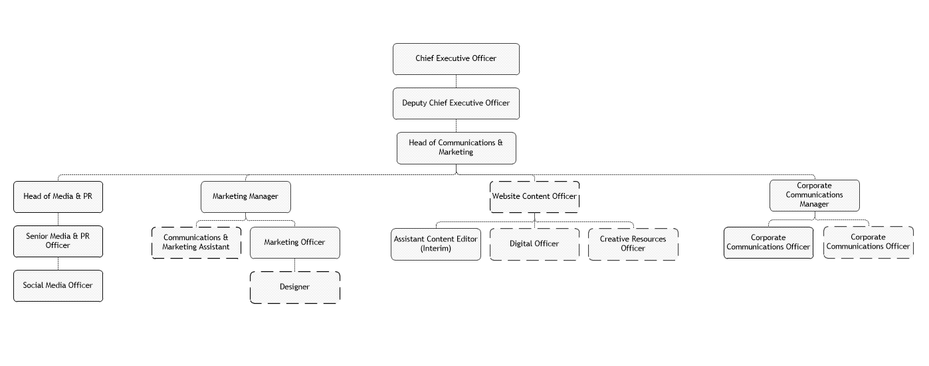
Main responsibilities of the role
Support the process of identifying quality content from older IOP websites and migrating to the new one. This will include writing or commissioning new content, rewriting/editing existing content to fit house style and best practice, finding strong new images and uploading content into the CMS manually.
Identify opportunities for new digital content and write, commission or edit ready for publishing.
Work with departments within the IOP to update and maintain digital content.
Follow the content strategy to ensure all digital material serves users’ needs and is best in class.
Help the website content editor to maintain accuracy and consistency of style and tone of all digital content, using our editorial guidelines.
Follow and enforce usability and accessibility standards for digital best practice.
Ensure content is SEO-friendly.
Use appropriate metrics to ensure continuous improvement of content and respond to user and member demand.
Work closely with the wider communications team to promote digital content effectively.

Person Specification
We are looking for someone who...
- Has a drive for results, who can be counted on to meet or exceed goals successfully
- Can manage and measure work effectively, taking responsibility for tasks and decisions
- Is customer focussed and dedicated to meeting the expectations and requirements of internal and external customers / partners
- Has great functional/technical knowledge and skills to do the job at a high level of accomplishment
- Is committed to their personal learning, picking up on the need to change personal, interpersonal, and where applicable managerial behaviour quickly
Experience this person should have is…
Essential:
- Demonstrable experience of producing great digital content, both writing and editing, across a range of formats
- Significant experience of digital content management, working with complex websites
- Experience of using content management systems (CMS) and related software for uploading content to the web
- Good knowledge of search engine optimisation (SEO) and how it impacts on written, image and video content
- Experience of using Google Analytics to assess day-to-day content decisions
- A great eye for a picture, with experience of finding and formatting strong images for use online using Photoshop or similar
- A clear understanding of good website practice and online principles, including usability and accessibility issues
- Experience with responsive design

Desirable:
- An understanding of and experience with other digital channels including social media and email
- Experience of using Drupal
- A working knowledge of HTML
- Previous experience with or an understanding of scientific content
- Experience with user testing
Skills this person requires are…
- Excellent digital writing and editing skills with the ability to create engaging and targeted digital content, with the user in mind
- Excellent proofreading skills and attention to detail
- Ability to recognise good digital content and make recommendations to improve content
- Ability to translate scientific, technical and operational information into plain English
- Highly organised, with excellent project management skills and the ability to manage several projects concurrently and prioritise workload
- Ability to work independently and refer upwards
- Good networking skills and the ability to work co-operatively with others to achieve common goals
- Good negotiation skills and the capability to explore different positions and alternatives to reach outcomes that gain acceptance of all parties
- Ability to think ahead and act to ensure the smooth completion of aims and objectives
- Ability to complete tasks to a high standard and to deadline
- Ability to positively communicate and interact with others; the confidence to listen and understand
Qualifications required are…
Degree level or equivalent in communications, digital media, digital marketing or similar, or significant experience with digital content in a professional capacity.

