Job Description
Job Title | Project Officer-Teaching Workforce | Grade | C
Department | Education & Workforce
Team | Education
Responsible to | Manager-Teaching Workforce
Revision date | 01 May 2025

Organisation Context
The Institute of Physics (IOP) is the national society for the discipline of physics in the UK and Ireland. As well as being a learned society, we are also the professional body for members based in the UK, Ireland, and overseas.

We are a professional, modern, and ambitious organisation seeking to unlock the potential of physics and physicists nationally and internationally. Our purpose is to promote the advancement and dissemination of knowledge and learning in pure and applied physics for the benefit of all. We do this by building a thriving and diverse physics workforce, raising standards, supporting careers, and addressing barriers.

We demonstrate the importance, relevance, and impact of physics in everyday life and the role it plays in addressing society’s major societal, economic, and environmental challenges. We influence change, actively engage in public and government dialogue, improving the quality of debate, informing policy, and influencing funding strategies. Above all, we are pioneering. We foster a sense of community amongst employees, members, volunteers, and people with an interest in physics, providing a platform and a voice for ideas to be heard and creating an environment which enables game-changing innovation.

Our organisational values are at the heart of IOP and provide the foundations to empower us all to lead cultural change, deliver high performance across the organisation, and enable us to promote advancements and learning in pure and applied physics for the benefit of all.

Our 2024–2029 strategy, titled "Physics for our Future," focuses on three key priorities: addressing the skills shortage and expanding opportunities in physics education; strengthening physics across science, research, innovation, and technology; and exploring and communicating the social and economic benefits of physics to ensure they are widely understood. The strategy emphasises collaboration within the physics community, inclusivity, and diversity, aiming to make physics accessible and welcoming to all. It also highlights the central role of IOP Publishing in supporting the organization's mission, with profits directed towards public benefit and scientific advancement.

Purpose of the role and accountabilities
The purpose of the Education and Workforce Department within IOP is to work towards equity of access to a high -quality physics education for all, across every stage of the education pipeline. In turn, unlocking opportunity for all, and helping ensure physics powered sectors have access to the diverse skills and talents they need to thrive.

This directly addresses the Skills priority in the IOP’s strategy: “tackling the skills shortage and opening up opportunity” as a diverse pool of skilled people is vital to fully realising the benefits of physics for society and the economy in the UK and Ireland.

The primary goal of our Skills priority clearly outlines this:

“The opportunities, knowledge and skills that physics can offer will be truly open to all – so we can better understand our world, shape rich and inspiring futures, and build thriving, resilient societies and economies ”.

In our strategy we commit to fighting for world class physics education for all young people and for measures to close the specialist physics teacher gap in schools through recruitment, retention and retraining. As part of this, we work with partners to promote the value of teaching, from primary to postgraduate education, advocate for relevant, inspiring curricula, and ensure educators have the tools and support they need to give every learner the best possible experience of physics.

The Project Officer, Teaching Workforce reports to the Manager, Teaching Workforce and forms an integral part of the Teaching Workforce mini-team which is collectively responsible for identifying and championing measures to address the specialist physics teacher shortage in schools and colleges. Where appropriate, the mini-team also delivers targeted interventions where these have the potential to scale impact effectively working closely with other teams in the department and wider IOP.

The role holder will play an important role supporting an ambitious programme of strategic research, evidence development and stakeholder influencing (in government and in the education community) to deliver impact against this issue.

Key decision-making

- Using sound judgement to work effectively across a range of priorities and stakeholders, identifying, managing and escalating opportunities, risks and challenges as needed.
- Identifying opportunities to positively develop and refine workflows, processes and systems.
- Feeding into decisions around the mini-team’s programme of work, and the scope and approach for individual activities and projects within that.

Key accountabilities

- Project Management: supporting the management of projects including coordinating the administrative activity of a portfolio of projects; flagging connections across projects and activities to maximise impact; ensuring Teams channels are well managed and key information is captured, indexed and tagged
- Support activities that contribute to building a strong and robust evidence base including supporting in person and online events: collection, collation and analysis of data, surveys, stakeholder engagement, development of presentations, other communication assets and reports
- Stakeholder mapping and management: including exemplary use of Salesforce CRM and excellent communication in engagement with stakeholders
- Financial data: budgetary monitoring of multiple project streams and subsequent outputs and assets: may authorise expenditure up to £1K
- Level of responsibility and risk: IOP reputational risk is medium to high potential to work directly with the Vice President for Education and Skills for specific project outputs and direct engagement with external stakeholders and partners, often at a senior level
- Internal cohesion: contributing to a joined-up approach to activities across IOP
- Key role in the implementation and delivery of research, data projects and outputs that build the knowledge and evidence base
- Working collaboratively with line manager and internal teams to support cross IOP initiatives such as Limit Less

Ways of working
The Teaching Workforce Project Officer will demonstrate collaborative, evidence-led, and impactful ways of working to achieve organisational objectives by:

- Building and maintaining effective working relationships across departments, encouraging knowledge sharing, alignment, and mutual support
- Working collaboratively with key colleagues within cross-cutting teams to ensure appropriate involvement in the Workforce team’s work: this includes Policy and Public Affairs, Communications and Marketing and EDI
- Maintaining knowledge of relevant emerging education related policy trends
- Maintaining open and transparent communication with the Manager- Teaching Workforce and within the E&WF Senior Management Team, with wider organisational colleagues, and with external stakeholders, balancing virtual and in-person interactions effectively
- Champion the coordination of alignment of all activities to deliver measurable outcomes, such as increased stakeholder engagement, improved reputation, and tangible progress on strategic goals
- Exemplify IOP’s values - objectivity, inclusivity, excellence, and openness - in all interactions and deliverables

Organisational chart
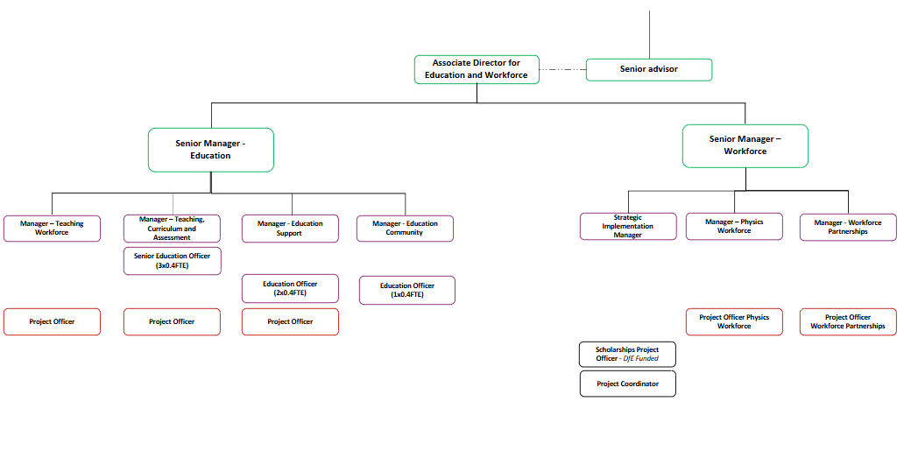

Main responsibilities of the role
Undertaking activities to support the development of a robust research and evidence base around: the factors underpinning the health of the physics teaching workforce and how best to create the conditions for this to thrive, leading on or supporting the Manager, Teaching Workforce on specific activities, as appropriate.
Supporting the use of data insights coupled with broader research and stakeholder intelligence to drive thought leadership, potentially including the identification of potential solutions.​
Supporting the writing and development of assets to promote our thought leadership, working with the wider team, leading on key outputs (or aspects of outputs) where appropriate.
Supporting the Manager, Teaching Workforce to develop relationships with key stakeholders in the education sector (including curating key networks of stakeholders such as the initial teacher training community) to drive the development of a strong knowledge and evidence base and provide a route to influence where needed.
Supporting the Manager, Teaching Workforce, working with the Communications & Marketing and Policy & Public Affairs departments, to execute influencing strategies to deliver impact against key priorities.
Following and promoting best practice in diversity and inclusion across all aspects of your work.
Contributing to a joined-up approach to stakeholder engagement and fundraising across IOP.
Providing other project support to the Manager, Teaching Workforce as reasonably required, for example, in helping meet internal reporting or briefing requirements, or managing individual projects that contribute to the mini-team’s goals.

Person Specification
We are looking for someone who…
Creativity and thought leadership: Can bring clear insight and creative, incisive thinking to bear on complex problems; is adept at analysing and using evidence to explore new solutions to major challenges; can provide intellectual leadership and direction to teams, individuals, programmes and projects.

Communication: Can help to bring data and evidence to life for specialist and non-specialist audiences using different methods and approaches; has excellent presentation and writing skills; can implement communications that encourages engagement from members, stakeholders and potential funders in our programmes and projects

Priority setting: Has a drive for results and can be counted on to manage involvement in multiple projects, meeting or exceeding goals; understands and uses time well to focus on what’s important; understands what will help or hinder progress and works collaboratively to eliminate roadblocks and maintain focus.

Planning: Effectively scopes out length and difficulty of tasks and projects; implements project plans, milestones and goals; anticipates problems and roadblocks; evaluates and measures performance that subsequently adds to the team knowledge base and a cycle of continuous improvement.

Assumes Responsibility: Willingly assumes responsibility for individual and collective undertakings. Understands importance of accountability, scrutiny and reporting to good governance and organisational management. Takes responsibility for the identification, assessment and management of risks and threats to the IOP, its programmes and projects.

Managing and Measuring Work: Takes responsibility for tasks and decisions appropriate to the level of the role; feeds progress and results back to line manager and ensures feedback is used to inform future work. Understands and shares responsibility and accountability to perform and complete work on time and within budget. Is committed to their personal learning, picking up the need to change personal and interpersonal behaviour quickly

Motivating Others: Contributes to a team and organisational climate for success; empowers others by inviting input and sharing ownership appropriate to the level of the role; values individual contributions and plays a part in creating a positive team environment by communicating openly and clearly.

Experience this person should have is…
Role specific experience

- Experience of working in a project-based environment with significant internal and external stakeholder interest. Note that formal project management qualifications are not a requirement.
- Experience working in a strategy, policy or public affairs-related background.
- An understanding of relevant aspects of the education policy landscape would be desirable (but is not essential, as support can be provided to develop on the job).
- This role does not require physics subject knowledge or teaching experience.

General criteria:

- Expertise in building and maintaining relationships with internal and external stakeholders to drive organisational success
- Skilled in the administration and PM of multiple projects and ensuring quality assurance through evaluation, reporting and monitoring processes and documentation
- Co-ordination of project budgets, liaising with project and finance leads
- Familiarity with cross-functional collaboration to drive project outcomes, fostering alignment across diverse teams and disciplines

Skills this person requires are…
- Team player – the ability to work co-operatively with others to achieve common goals
- Proactive – to think ahead and act to ensure the smooth and timely completion of team/individual aims and objectives
- Dependable – able to complete tasks to high standard and to deadline
- Organisational skills – ability to work with minimum supervision, prioritise workload, and handle multiple tasks
- Interpersonal skills – ability to positively communicate with others; the confidence to listen and understand
- Computer literate – good working knowledge of Microsoft Office applications and CRM and other communication systems
- Communication – High level written and verbal communication skills. Ability to communicate clearly and effectively with members, colleagues and external stakeholders
- Flexibility – the ability to amend work and project plans whilst responding to changing circumstances
- Relationship management - people skills, tact and diplomacy to manage relationships with stakeholders including members who volunteer their time and expertise

Qualifications this person requires are…
- GCSE English and Mathematics at Grade C or above, or equivalent (essential)
- Recognised administrative and/or project management qualification, e.g. City & Guilds, Pitman, APM etc. (desirable)

