Job Description
Job title | Public Engagement Manager | Grade | B
Department | Public Engagement
Responsible to | Head of Public Engagement & Dialogue
Revision Date | August 2025

Organisation Context
The Institute of Physics (IOP) is the national society for the discipline of physics in the UK and Ireland. As well as being a learned society, we are also the professional body for members based in the UK, Ireland, and overseas.
We are a professional, modern, and ambitious organisation seeking to unlock the potential of physics and physicists nationally and internationally. Our purpose is to promote the advancement and dissemination of knowledge and learning in pure and applied physics for the benefit of all. We do this by building a thriving and diverse physics workforce, raising standards, supporting careers, and addressing barriers.
We demonstrate the importance, relevance, and impact of physics in everyday life and the role it plays in addressing society’s major societal, economic, and environmental challenges. We influence change, actively engage in public and government dialogue, improving the quality of debate, informing policy, and influencing funding strategies. Above all, we are pioneering. We foster a sense of community amongst employees, members, volunteers, and people with an interest in physics, providing a platform and a voice for ideas to be heard and creating an environment which enables game-changing innovation.
Our organisational values are at the heart of IOP and provide the foundations to empower us all to lead cultural change, deliver high performance across the organisation, and enable us to promote advancements and learning in pure and applied physics for the benefit of all.
Our 2024–2029 strategy, titled "Physics for our Future," focuses on three key priorities: addressing the skills shortage and expanding opportunities in physics education and careers; strengthening physics across science, research, innovation, and technology; and exploring and communicating the social and economic benefits of physics to ensure they are widely understood. The strategy emphasises collaboration within the physics community, inclusivity, and diversity, aiming to make physics accessible and welcoming to all. It also highlights the central role of IOP Publishing in supporting the organisation's mission, with profits directed towards public benefit and scientific advancement.

Team context:

The IOP’s Public Engagement and Public Dialogue champions and shares the value of Physics to society, to ensure the future health of our discipline.

The aim of IOP’s Public Engagement is to change the perception of physics and tackle stereotypes that exclude many potential future physicists. Framed by the aims of Limit Less (www.iop.org/LimitLess) we aim to engage with families with young people who are currently underrepresented in physics from the age of 16.
We do this by sharing the human stories of physics, especially with families, using messages framed by the aims of the Limit Less initiative.

We develop and run a national programme of public engagement with an annual theme to provide focus and enhance impact. Developed collaboratively with IOP colleagues, this annual theme provides a strategic framework for the public engagement delivered by our members.

We support physicists in general and our members in particular to be positive role models for our family audience.

We support the ambitions for the IOP in engaging public audiences in dialogue about how physics is providing solutions to the global challenges facing society. We support the physics sector to listen to the public so it can better represent the interests of society.

Purpose of the Role and Accountabilities
One of the key strategic aims of the IOP is to increase the number of young people doing physics after the age of 16, particularly those from currently under-represented audiences. The IOP’s Public Engagement programme is designed and delivered through the lens of our Limit Less initiative (www.iop.org/LimitLess).

In support of this aim, the post holder will manage and deliver a portfolio of engagement events and activities with family audiences across the UK and Ireland as part of the Public Engagement and Dialogue team at the IOP.

They will work collaboratively with colleagues across the organisation to develop engagement capacity within our Membership and the physics community more broadly by creating and supporting volunteering opportunities and encouraging physicists to be relatable role models for young people and their influencers.

The role holder is a visible advocate and ambassador for the IOP’s Public Engagement both with IOP colleagues and Members and external stakeholders. When required, this will involve public speaking and representing the IOP at key events.

In addition, the role supports the growing Public Dialogue ambitions of the IOP and will be part of project teams as they develop.

The role holder has financial authority to approve spend up to £5,000 (and Euro equivalent)

The Public Engagement Manager reports to the Head of Public Engagement & Dialogue.

Please note, extensive travel will be required for this role as it is responsible for developing and delivering public engagement activities across the UK and Ireland.

Ways of Working
At IOP, we are committed to fostering a collaborative, inclusive and impact driven working environment.
All colleagues are expected to:
- Work collaboratively across teams and functions to deliver shared goals and contribute to a culture of transparency and mutual support.

- Demonstrate integrity by being a good corporate citizen, ensuring that work is evidence based, impartial and aligned with IOPs strategic priorities.

- Champion diversity and inclusion, actively contributing to an environment where everyone feels respected, valued and able to thrive.

- Engage constructively with stakeholders, to promote the value and impact of physics.

- Embrace flexibility and innovation, adapting to change and seek continuous improvement in how we work and deliver services.

- Take ownership and accountability for individual and team outcomes, upholding high standards or professionalism and conduct

Additionally, the Public Engagement Manager will demonstrate collaborative, evidence-led, and impactful ways of working to achieve organisational objectives by:
- Working collaboratively across multiple teams, especially the IOP’s National and Membership teams, the Equality, Diversity & Inclusion (EDI) team, including colleagues who are part of the Limit Less initiative – and the Communications and Marketing team
- Supporting high-quality content design and delivery, so there is diverse and effective public engagement framed by the aims of the Limit Less initiative.
- Supporting the monitoring and evaluation of public engagement initiatives to ensure they meet defined KPIs and organisational objectives
Organisational chart
The Institute of Physics is an open and inclusive organisation that welcomes and celebrates diversity.

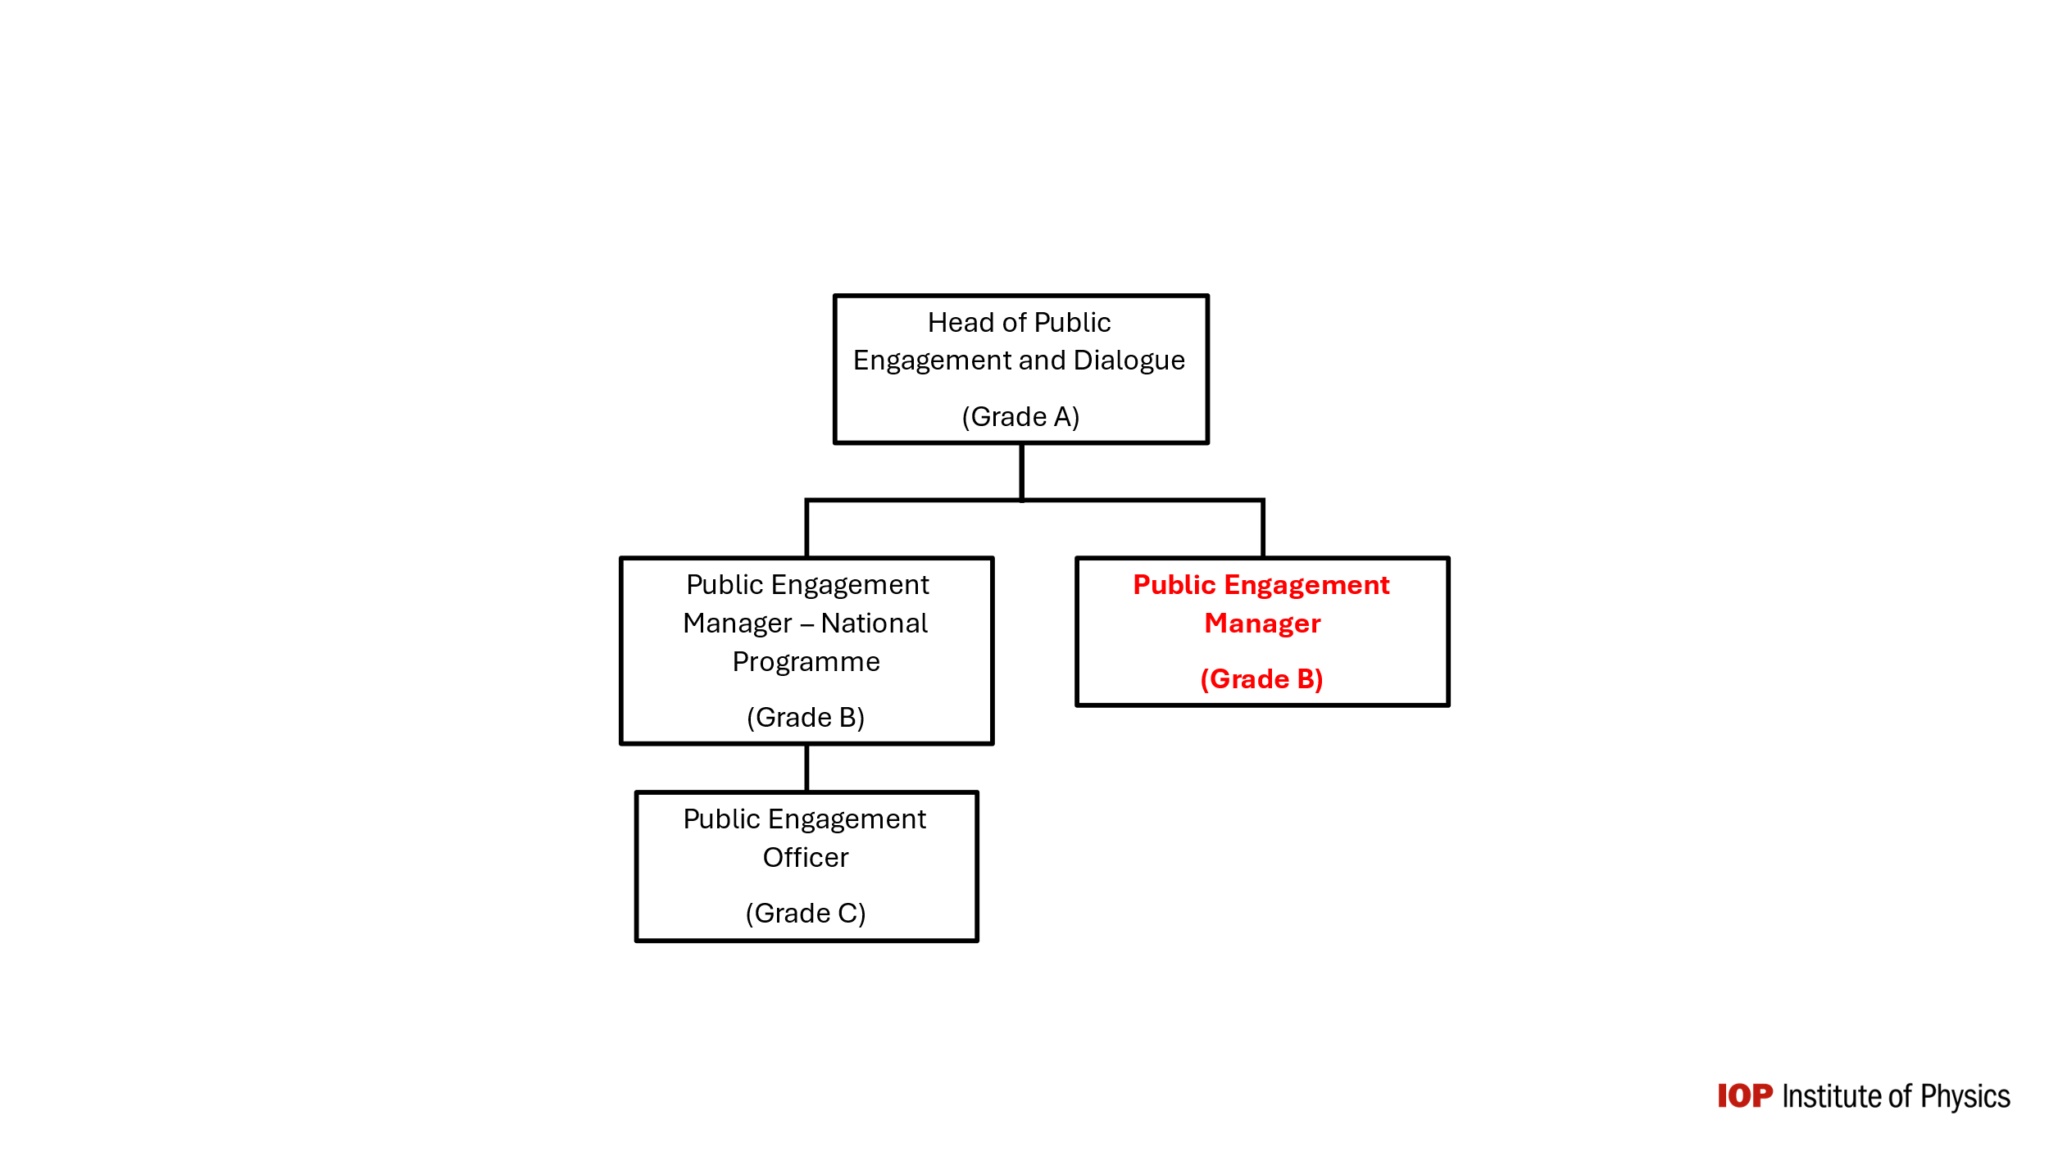

Main responsibilities of the role

- The development and delivery of the overall national public engagement programme is led by the Public Engagement Manager – National Programme. Collaborating with them and colleagues in the Public Engagement team the role holder supports the development of the national programme and the London and Dublin exhibitions, including identifying relatable role models and creating resources for volunteer physicists and IOP members.

- Managing a portfolio of public engagement events, including the delivery of the summer exhibition in Dublin over the course of 3-4 weekends in July and August each year and public engagement events across NI, Scotland and Wales

- Working with colleagues from across the organisation, particularly those in the Membership and National teams to support member led or member involved approaches to public engagement, with members supported and enabled to deliver appropriate activities that impactfully contribute to the IOP’s strategic goals. This includes being a strategic touchpoint to support Members in best practice for the outreach grant schemes run by the IOP’s National Committees, bringing public-facing projects in line with the aims of the IOP’s Limit Less initiative

- Support the development of public engagement content that demonstrates the value of physics and its applications to our lives and the full range of career and education pathways that can be accessed through doing physics

- Support the evaluation of Public Engagement Events to ensure the ongoing improvement pf our programme

- Assisting with identifying fundraising opportunities for public engagement around the UK and Ireland and contribute to the fundraising bids as they develop

- Support the Limit Less framing of member-led or member involved public engagement by working with colleagues in the National and Membership teams and the Limit Less initiative within the Equality, Diversity & Inclusion (EDI) team.
- In the future, as part of the Public Engagement team, support the IOP in developing and delivering a small number of high impact public dialogue initiatives, working in collaboration with colleagues from across the IOP.

All IOP colleagues are responsible for:
- Embedding EDI best practise and the IOP’s values in the delivery of all aspects of their work

- Identifying, assessing and managing risks and threats to the IOP, its programmes and projects within their specialism.
- Encouraging best practice in managing, following and promoting IOP EDI standards through their work, interaction with colleagues, stakeholders and members.

Person Specification
Essential experience this person should have:
Role-specific experience:

- Experience of delivering high quality, impactful public engagement (ideally within a membership organisation and/or for family audiences)
- Working with researchers and others from across the scientific community to develop, deliver and evaluate public engagement activities, particularly those involving volunteers

- Experience of translating complex physics ideas into family-friendly narratives for public engagement activities

- Proven experience of engaging with diverse and under-represented communities and, particularly, with family audiences from these communities

General experience:

- Experience in both written and oral communication, with confidence in presenting to others, including public. audiences and stakeholders

- Experience in building and maintaining relationships with internal and external stakeholders to support organisational success

- Experience of managing budgets for small- and medium-sized projects (e.g. £1,000 to £10,000)

- Good computer literacy, including good working knowledge of MS Office and CRM programs

Required skills:
- Creative – innovative ways to bring about change in public understanding through public engagement and dialogue.
- Interpersonal – ability to communicate positively with others and the confidence to listen, understand and where necessary adapt ways of working.

In addition to:

- Planning: Scopes out length and difficulty of tasks and projects; measures performance against goals and evaluates results and impact.

- Collaboration: Understands and shares responsibility and accountability working with the Public Engagement team and with other IOP teams; trusts others to perform and lets others complete work.

- Managing and Measuring work: Is clear taking on the responsibility for tasks and decisions with clear objectives and measures, monitors regularly for progress and results and ensures learning from feedback is used to inform future work.

- Priority Setting: Ability to work independently and prioritise. Understands and uses time well to spend on what’s important; understands what will help or hinder progress and eliminates roadblocks and creates focus.

- Customer Focus Understands and is committed to meeting the requirements of customers, both internally and externally; uses customer feedback to inform improvements in services. This includes our public audiences and our Membership and the wider physics community with whom we collaborate and draw from in order to deliver our programme.

Required qualifications:
- A degree in physics, science related or astronomy – essential

- Qualification in science communication – desirable

